**ABSTRACT**

Image classification refers to the task of extracting information classes from a [multiband](https://desktop.arcgis.com/en/arcmap/latest/manage-data/raster-and-images/raster-bands.htm#GUID-203F9D69-BEAB-4FF3-8153-336B5029F33E) raster image. The resulting raster from image classification can be used to create thematic maps. Depending on the interaction between the analyst and the computer during classification, there are two types of classification: supervised and unsupervised.

The problem of region classification in scenery/landscape images is gaining importance with an increase in the demand for automated, reliable, fast and efficient recognition which can make classification of images more important.

It has become very difficult task to classify the images into interpretative classes. Apart from various learning algorithms the accuracy and performance of the model mostly depends on the trained dataset and the algorithm used. Here we have proposed a system to classify the scenery images into different groups of glaciers, street, mountains, trees, buildings and sea.

|  |  |  |  |  |  |  |
| --- | --- | --- | --- | --- | --- | --- |
| **Chapter No.** | **Table of Contents** | | | | | **Page No.** |
| **1.** | **Introduction** | | | | | **1** |
|  | 1.1 | Over view of the project | | | | **.** |
|  | 1.2 | Motivation | | | | **.** |
|  | 1.3 | Objectives of the project | | | |  |
|  | 1.4 | Problem definition | | | |  |
| **2.** | **Proposed System** | | | | | **.** |
|  | 2.1 | Description of proposed system with simple block diagram | | | |  |
|  | 2.2 | Description of Target users | | | |  |
|  | 2.3 | Advantages/applications of proposed system | | | |  |
|  | 2.4 | Scope (Boundary of proposed system) | | | |  |
|  | 2.5 | ~~Gantt chart~~ | | | |  |
| **3.** | **Software Requirement Specification** | | | | |  |
|  | 3.1 | Overview of SRS | | | |  |
|  | 3.2 | Requirement Specifications | | | |  |
|  |  | 3.3.1 | | Functional Requirements | |  |
|  |  | 3.3.2 | | Use case diagrams | |  |
|  |  | 3.3.3 | | Use Case descriptions using scenarios, strictly as per Pressman Template | |  |
|  |  | 3.3.3 | Nonfunctional Requirements | | |  |
|  |  |  | | 3.3.3.1 | Performance requirements ( if applicable ) |  |
|  |  |  | | 3.3.3.2 | Safety requirements ( if applicable ) |  |
|  |  |  | | 3.3.3.3 | Security Requirements( if applicable ) |  |
|  |  |  | | 3.3.3.4 | Usability |  |
|  |  |  | | 3.3.3.5 | Any other |  |
|  | 3.4 | Software and Hardware requirement specifications | | | |  |
|  | 3.6 | ~~GUI of proposed system (snap shots)navigation from Home screen to end results~~ | | | |  |
|  | 3.8 | ~~Acceptance test plan~~ | | | |  |

APPENDIX

References

**// Example:**

[1] G.K.Patnaik and M. M. Gore, “Design of Compiler for Mobile Environment and it’s formalization using Evolving Algebra ”, *proceedings of 3rd IEEE International Conference on Mobile Data Management, Singapore, January 2002, PP 159-160.*

[2] “Author Guidelines”, *http://.computer.org/cspress/instruct.htm*

*Note: strike-out topics

should be included in the next review

1. **INTRODUCTION**

Image classification is perhaps the most important part of digital image analysis .Rapid advances in computer vision and ongoing research has provided ways to create solutions that enable automated image tagging and automatically add tags to images to allow users to search and filter more quickly.

**1.1 Over view of the project**

The man in the persuit of unravelling the nature,has tried to understand the building blocks of the universe.

It helps to simplify the work of predicting the behaviour of images based on their properties.

The term image classification refers to the labelling of images into one of a number of predefined categories. Classification is a task to identify the class/category of new instance based on training set.

The Dataset contains around 25k images of size 150x150 distributed under 6 categories. {'buildings' -> 0, 'forest' -> 1, 'glacier' -> 2, 'mountain' -> 3, 'sea' -> 4, 'street' -> 5 }, we classify an image into one of the predefined classes or multiple classes at the same time. There are around 14k images in Train, 3k in Test and 7k in Prediction. With the rapid increase of digital photography, image understanding becomes increasingly important.

**1.2 Motivation**

Image identification powered by innovative machine learning has already been embedded in a number of fields with impressive success. It is used for [automated image organization of large databases and visual websites](https://imagga.com/blog/the-top-5-uses-of-image-recognition/), as well as face and photo recognition [on social networks such as Facebook](https://imagga.com/blog/4-image-recognition-uses-by-facebook-that-can-improve-digital-asset-management/). Image recognition makes [image classification for stock websites](https://imagga.com/blog/image-recognition-powers-stock-photo-video-industry-today/) easier, and even fuels marketers’ creativity by enabling them [to craft interactive brand campaigns](https://imagga.com/blog/image-recognition-is-changing-interactive-marketing/).

Classification is very important as we use it in daily life. It makes things easier to find and recognise. Differentiation of objects is what allows us to classify them into groups.

 In this section we will introduce the Image Classification problem, which is the task of assigning an input image one label from a fixed set of categories. This is one of the core problems in Computer Vision that, despite its simplicity, has a large variety of practical applications. Moreover, as we can see, many other seemingly distinct Computer Vision tasks (such as object detection, segmentation) can be reduced to image classification.

**1.3 Objectives of the project**

* Identify color and texture of the image
* Identify the object and classify into respective group.

**1.4 Problem definition**

Develop a system to classify images based on scenery i.e buildings, forest, sea, glaciers etc

1. **Proposed System**
   1. **Description of proposed system with simple block diagram**

Learning Algorithms

Preprocessing

Features

Input image

Label Assignment

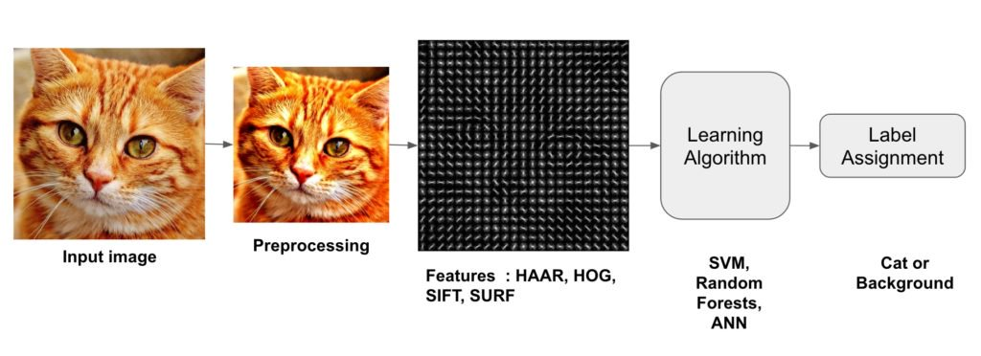

* 1. **Description of Target users**

User: He should be able to upload the image ,view image category and view all images in the respective category

Admin: He should be able to upload the image dataset for training the model .

**2.3 Advantages/applications of proposed system**

* **Drones:** Drones equipped with image classification and recognition capabilities can provide vision-based automatic monitoring, inspection, and control of the assets located in remote areas.
* **Military Surveillance:** Detection of unusual activities in the border areas and automatic decision-making capabilities can help prevent infiltration and result in saving the lives of soldiers.
* Searching: Faster searching of images .
* **Forest Activities:**Unmanned Aerial Vehicles can monitor the forest, predict changes that can result in forest fires, and prevent poaching. It can also provide a complete monitoring of the vast lands, which humans cannot access easily.
  1. **Scope**
* The proposed system can be used in any robots so that it can recognise the images and classify.

**3. Software Requirement Specification**

**3.1 Overview of SRS**

A software requirements specification (SRS) is a description of a software system to be developed. It lays out functional and non-functional requirements, and may include a set of use cases that describe user interactions that the software must provide. Software requirements specification establishes the basis for an agreement between customers and contractors or suppliers (in market-driven projects, these roles may be played by the marketing and development divisions) on what the software product is to do as well as what it is not expected to do. It should also provide a realistic basis for estimating product costs, risks, and schedules. Used appropriately, software requirements specifications can help prevent software project failure.

* 1. **Requirement Specifications**
     1. **Functional Requirements**
        1. **User level**
           1. User shall be able to upload images.
           2. User shall be able to view images.
           3. User shall be able to see the category under which it belongs to.
           4. User shall be able to view all images under particular category.
        2. **System level**
           1. System shall be able to store data in database.
           2. System shall be able to generate category under which it belongs to.
           3. System shall be able to generate all images under particular category.
           4. System shall be able to generate error message for invalid input.
           5. System shall not be able to accept the image exceeding 30KB.

**3.3.2 Use case diagrams**

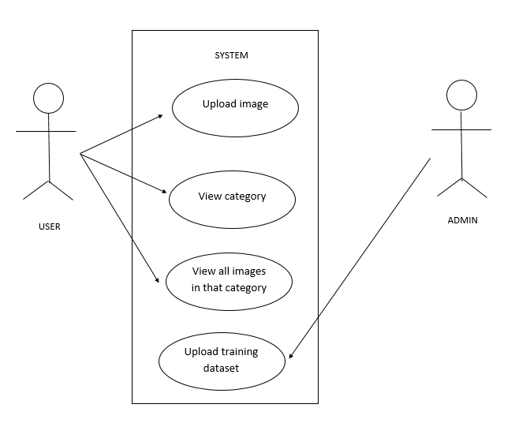

**3.3.3 Use case descriptions using scenarios**

* Use case:1

|  |  |
| --- | --- |
| Use case: | Upload image |
| Actors: | User |
| Goal in context: | Image should be uploaded properly. |
| Precondition: | Should have image🡪Scenery.  🡪The system should accept scenery image.  🡪The image should not be corrupted. |
| Post condition: | 🡪The user should be able to upload the image for classification |
| Main success scenario: | User image is uploaded successfully. |
| Exception scenario: | 🡪Image size exceeds 30Kb.  🡪The system has crashed due to some internal error |

* Use case:2

|  |  |
| --- | --- |
| Use case: | View image category |
| Actors: | User |
| Goal in context: | User should be able to view the category name to which image belongs |
| Precondition: | 🡪Image is able to view category name |
| Post condition: | 🡪The user is able to see the image category in the system. |
| Main success scenario: | The user is able to view all the specified properties and store them successfully in readable format. |
| Exception scenario: | 🡪The system crashes.  🡪Algorithm failed to run at runtime. |

* Use case:3

|  |  |
| --- | --- |
| Use case: | View all images in that category |
| Actors: | User |
| Goal in context | User should be able to view all images under that category |
| Precondition: | 🡪Image should be uploaded properly.  🡪The image category should be properly specified. |
| Post condition: | 🡪The user is able to see all the images in that category present in the system. |
| Main success scenario: | The user is able to view all the category images. |
| Exception scenario: | 🡪The system crashes.  🡪Algorithm failed to run at runtime. |

* Use case:4

|  |  |
| --- | --- |
| Use case: | Upload training dataset |
| Actors: | Admin |
| Goal in context: | Admin must be able to upload the dataset successfully |
| Precondition: | 🡪Scenery image dataset should be available.  🡪Model should be able to take the dataset as input for training. |
| Post condition: | The image dataset is uploaded into the model. |
| Main success scenario: | The dataset is uploaded properly |
| Exception scenario: | 🡪The dataset contains image which is not a scenery based image.  🡪image dataset was not uploaded properly |

* + 1. **Non-Functional Requirements**

**3.3.3.1 Ease of use**

**3.3.3.1.1** The user should be able to use all it’s features with ease.

**3.3.3.1.2** The system should indicate fields , suggestions when some error pop up.

**3.3.3.2** **Compatibility**

**3.3.3.2.1** The system should be compatible with any browser on any environment.

**3.3.3.3** **Scalability**

**3.3.3.3.1** The system should be able to expand for further storing.

**3.3.3.4 Performance**

**3.3.3.4.1** The system should be able to produce output in less than 5 seconds.

**3.3.3.5 Size of the image**

**3.3.3.5.1** The size of image should not exceed 30KB.

**3.3.3.6 Maintainability**

**3.3.3.6.1** The system should have long life.

**3.3.3.6 Reliability**

**3.3.3.6.1** The system should be able to perform a failure-free operation for a specified period of time in a specified environment.

* 1. **Software and Hardware requirement specifications**

Hardware requirements

* Any CPU (Intel i5/ i7/ Xeon recommended).
* A minimum of 2 GB of RAM
* Keyboard and a Microsoft Mouse or some other compatible pointing device
* Internet Connection Broadband (high-speed) Internet connection with a speed of 4 Mbps or higher

Software requirements

* Windows 8, 10, 64 /32 bits
* Java -- To view and interact with all available blackboard applications
* Browsers: Chrome* 36+, Edge* 20+, Mozilla Firefox 31+, Internet Explorer 11+ (Windows only), Safari 6+ (MacOS only)